pip

What is Pip
# Source: AI Source: Provided by: [Data Path: Persons Table -> ID Column: 1, Name_En Column: Motasem Essam] -> From: [ChatGPT] on [1/26/2026]
pip is the package manager for the Python language.
It is used to install, update, and remove Python libraries (packages).

Simple Definition
# Source: AI Source: Provided by: [Data Path: Persons Table -> ID Column: 1, Name_En Column: Motasem Essam] -> From: [ChatGPT] on [1/26/2026]
pip = a tool that downloads and installs Python packages from the internet.
Most packages come from Python Package Index (PyPI).

Common pip Commands

Install a package
# Source: AI Source: Provided by: [Data Path: Persons Table -> ID Column: 1, Name_En Column: Motasem Essam] -> From: [ChatGPT] on [1/26/2026]
Syntax:
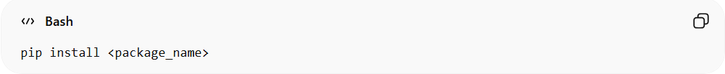
pip install <package_name>
Example:
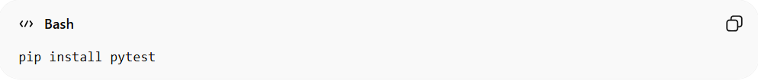
pip install pytest
Explain:
- Downloads the package from the Python Package Index.
- Installs it into your Python environment.
- After installation, the package can be imported and used in Python programs.
usage in Python:
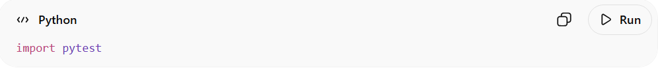
import pytest

Upgrade a package
# Source: AI Source: Provided by: [Data Path: Persons Table -> ID Column: 1, Name_En Column: Motasem Essam] -> From: [ChatGPT] on [1/26/2026]
Syntax:
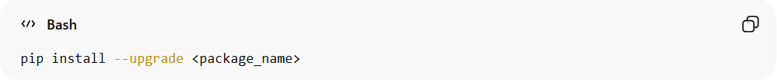
pip install --upgrade <package_name>
Example:
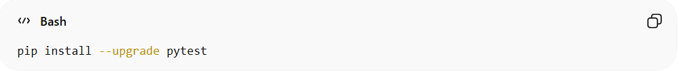
pip install --upgrade pytest
Explain:
- Updates the installed package to the latest available version.
- Useful when you want bug fixes or new features.

Remove a package
# Source: AI Source: Provided by: [Data Path: Persons Table -> ID Column: 1, Name_En Column: Motasem Essam] -> From: [ChatGPT] on [1/26/2026]
Syntax:
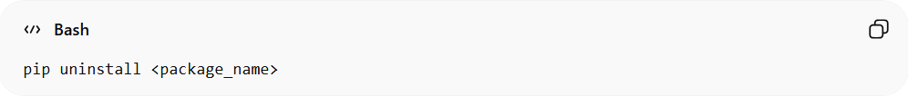
pip uninstall <package_name>
Example:
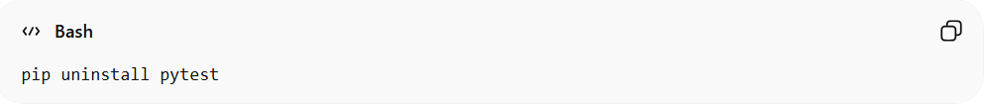
pip uninstall pytest
Explain:
- Removes the package from the Python environment.
- pip will ask for confirmation before uninstalling.

List installed packages
# Source: AI Source: Provided by: [Data Path: Persons Table -> ID Column: 1, Name_En Column: Motasem Essam] -> From: [ChatGPT] on [1/26/2026]
Syntax:
pip list
Example:
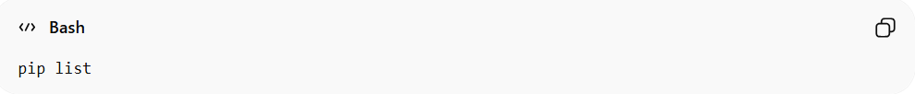
pip list
Explain:
- Shows all installed Python packages.
- Displays the package name and version.
Example output:
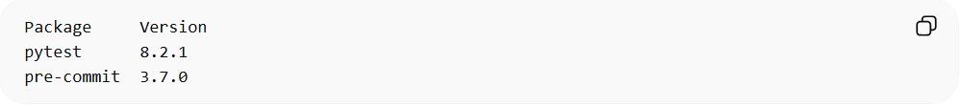
Package Version
pytest 8.2.1
pre-commit 3.7.0

Install Packages from a Requirements File
# Source: AI Source: Provided by: [Data Path: Persons Table -> ID Column: 1, Name_En Column: Motasem Essam] -> From: [ChatGPT] on [1/26/2026]
Syntax
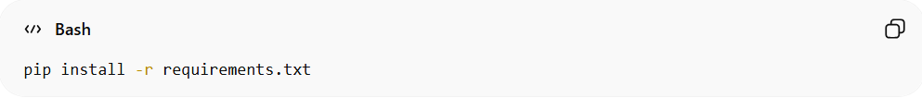
pip install -r requirements.txt
Example
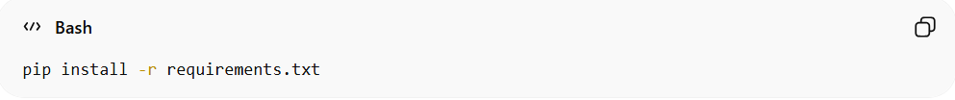
pip install -r requirements.txt
Explain:
- Installs multiple packages listed in a file.
- Commonly used in team projects.
Example requirements.txt:
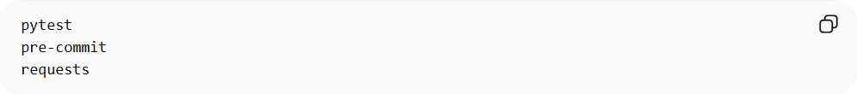
pytest
pre-commit
requests
Running the command installs all packages automatically.

Where pip is used
# Source: AI Source: Provided by: [Data Path: Persons Table -> ID Column: 1, Name_En Column: Motasem Essam] -> From: [ChatGPT] on [1/26/2026]
pip is used when working with:
- Python projects
- automation scripts
- testing frameworks
- web frameworks
Examples of tools installed with pip:
- pytest
- Django
- Flask
- pre-commit

Example Workflow
# Source: AI Source: Provided by: [Data Path: Persons Table -> ID Column: 1, Name_En Column: Motasem Essam] -> From: [ChatGPT] on [1/26/2026]
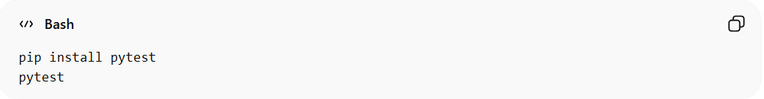
pip install pytest
pytest
This installs the testing tool and runs tests.

✅ Short summary
# Source: AI Source: Provided by: [Data Path: Persons Table -> ID Column: 1, Name_En Column: Motasem Essam] -> From: [ChatGPT] on [1/26/2026]
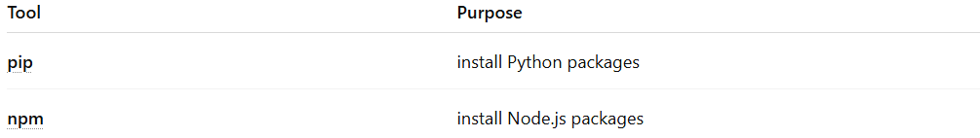
Tool | Purpose
pip | install Python packages
npm | install Node.js packages

